Here Technologies

Lidar Field Unit Return Testing: Intensity Test Results

Date: 12/5/2017

By: Kenneth laws

Unit SN 711024674

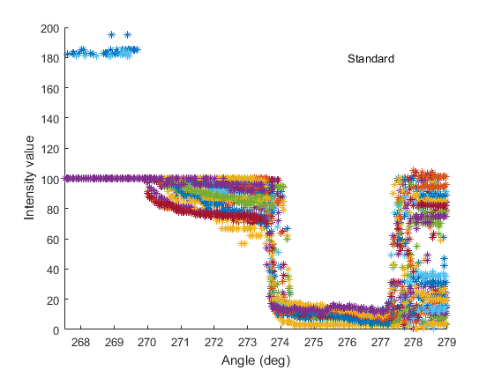

Intensity reference standard based on Here Technologies lidar intensity reference surface. Color indicates laser position. There are 3 different reflective surfaces, 268 – 270 deg (max reflectivity), 270 to 274 deg (medium reflectivity), 274 to 277 deg (low reflectivity). Intensity value of 100 indicates 100% diffuse reflector.



Intensity scan results for unit under test.

SN 711024674 matched the symptom of too easily saturated at 100% diffuse reflector.